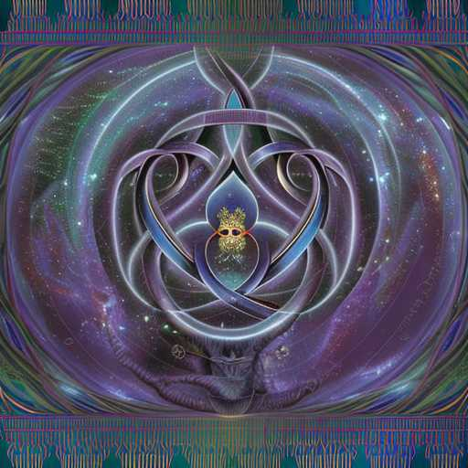
COMPASSION & THE WOMB OF WISDOM v.4

Atziluth
Briah
Fire and water
Sparks and steam
Spiral and stars
Compassion & the Womb of Wisdom
Love
Beauty
Mercy
Grace
Benevolence
Space Breathes
Splendor & Glory
Immaculate Heart beams of light
Queen of Angels
Effulgent
Vibrant
Blessing

